Breast Tumor Classification with Random Forest + Pattern Segmentation
(UCI WDBC)
Team Name / Cohort: Team 2 (Data Wranglers)
Team Members + Roles: Nelson, Arun, Nilesh, Vasant
Dataset: UCI Breast Cancer Wisconsin (Diagnostic)
Model: Random Forest Classifier (single algorithm)

1. Executive Summary
Objective.
This project addresses a supervised classification problem using the Breast Cancer Wisconsin (Diagnostic) dataset to distinguish Malignant (M) from Benign (B) tumors based on 30 quantitative diagnostic features derived from fine needle aspirate (FNA) images. The primary objective is to build a reproducible machine learning pipeline that prioritizes reliable detection of malignant cases while maintaining balanced overall performance.
Approach.
A single Random Forest Classifier was developed following a disciplined machine learning workflow, including data validation, preprocessing, and stratified train/validation/test splitting. Hyperparameters were optimized using cross-validated tuning to improve generalization performance. Model decision thresholds were adjusted based on recall–precision trade-offs to better control false negatives. In addition, unsupervised clustering (K-means and hierarchical clustering) was applied on scaled features to identify distinct diagnostic pattern groups and support interpretability of tumor characteristics beyond pure classification.
Key Results (Test Set).
The finalized model achieved strong discriminatory power and stable classification performance:
- ROC–AUC: 1.0
his means the model has perfect discriminatory ability between the two classes (Malignant vs Benign).
- Recall (Malignant): 0.9375
This means the model correctly identifies about 94% of all malignant tumors.
- Precision: 1.0
This means every case predicted as Malignant was actually Malignant.
- F1-score: 0.96
This means the model has an excellent balance between precision and recall.
These results indicate that the model effectively separates malignant from benign tumors while maintaining a favorable balance between sensitivity and precision.
Operational Interpretation (Triage Scenario).
In a triage(patients sorted by urgency- critical, moderate & Minor)-like screening context, the model’s emphasis on high recall for malignant cases reduces the risk of missing potentially dangerous tumors (false negatives). Patients predicted as high-risk can be flagged for immediate clinical review, while low-risk cases may be deprioritized for further testing. This supports efficient allocation of diagnostic resources and improves early detection potential, although the system is intended for decision support rather than clinical diagnosis.
Top Recommendations.
- Prioritize recall when setting the decision threshold
Given the small proportion of missed malignant cases (~6%), adjust the classification threshold to further increase recall for malignant tumors.
- Use the model as a triage support tool rather than a diagnostic system
The model’s perfect precision and near-perfect recall make it well suited for prioritizing high-risk patients for immediate clinical review, while low-risk predictions can be routed for routine follow-up, ensuring efficient use of medical resources.

- Validate the model on external or future patient data before deployment
The exceptionally high ROC–AUC suggests strong separability on the current dataset, but independent validation is necessary to confirm robustness and prevent overconfidence due to dataset-specific patterns.

2. Problem Definition and Success Metrics
Target Definition.
The objective is to classify breast tumors as Malignant (M) or Benign (B) using diagnostic features from the Breast Cancer Wisconsin (Diagnostic) dataset. The target variable Diagnosis was encoded as M = 1 (positive class) and B = 0 (negative class) so that model performance could be evaluated with emphasis on detecting malignant cases.
Meaning of Errors.
- False Negative (M predicted as B): This represents a malignant tumor incorrectly classified as benign. This is the most critical error because it may delay diagnosis and treatment, potentially leading to severe clinical consequences.
- False Positive (B predicted as M): This represents a benign tumor incorrectly flagged as malignant. While not life-threatening, it can cause patient anxiety, unnecessary follow-up tests, and increased healthcare costs.
Primary Evaluation Metrics
- ROC–AUC: Used to measure overall class separability across all thresholds and assess the model’s ability to distinguish malignant from benign tumors.
- Recall (Malignant): Prioritized to minimize false negatives and ensure most malignant cases are correctly identified.
- F1-score: Used to balance precision and recall, providing a single measure of classification quality for malignant detection.
Decision Threshold.
A probability threshold of 0.31 was used as the operating point for classification, as it provides a balanced trade-off between recall and precision while maintaining very high sensitivity for malignant cases. This threshold was chosen to support a triage-style use case, where reducing missed malignant cases is more important than avoiding false alarms.
3. Dataset Overview and Quality Checks
Dataset Facts.
The study uses the Breast Cancer Wisconsin (Diagnostic) dataset from the UCI Machine Learning Repository. It contains 569 instances and 30 real-valued diagnostic features, with the task framed as a binary classification problem to predict tumor diagnosis as Malignant (M) or Benign (B). The dataset contains no missing values, allowing direct use of all features after validation.
Feature Origin.
All input features are computed from digitized images of fine needle aspirate (FNA) samples of breast masses. These features quantify characteristics such as radius, texture, perimeter, area, smoothness, and concavity, providing objective measurements derived from medical imaging.
Quality Checks Performed.
- The ID column was removed from the feature set to prevent data leakage, as it does not carry predictive medical information.
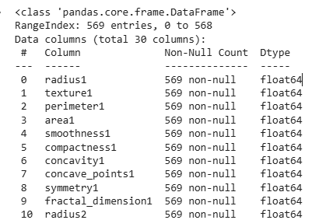
- The dataset was checked for duplicate records, and no duplicate observations were found.
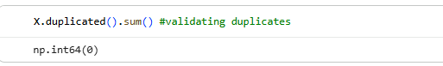
- Class distribution was examined and reported to ensure awareness of class imbalance between malignant and benign cases, with both absolute counts and percentage proportions documented.
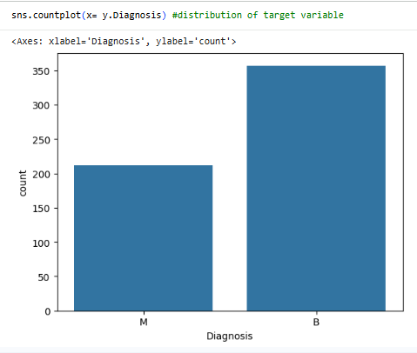 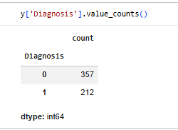
- An outlier handling policy was defined: no outliers were removed, as extreme values may represent clinically meaningful tumor characteristics rather than data error
4. Data Preparation and Split Strategy
Preprocessing Steps.
Data preparation began with removing non-informative columns, specifically the unique ID column, to prevent leakage. The target variable Diagnosis was encoded as Malignant (M) = 1 and Benign (B) = 0 to support binary classification and metric computation. Since all features are numerical and the Random Forest algorithm is scale-invariant, no feature scaling or normalization was applied for the supervised model. No additional feature transformations were performed.
Split Method.
A stratified Train/Validation/Test split strategy was used to preserve the original class distribution of malignant and benign cases across all subsets.
Split ratio: 70% / 15% / 15% (Train / Validation / Test)
Random seed: 42 (fixed for reproducibility)
The training set was used for model fitting, the validation set for hyperparameter tuning and threshold
analysis, and the test set was held out for final, one-time evaluation.
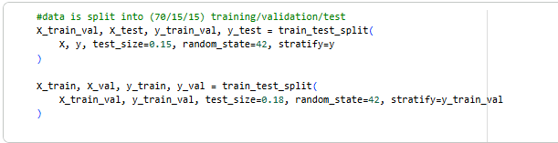
Leakage Prevention.
Strict leakage prevention practices were followed. All preprocessing decisions were finalized before model training, and no information from the validation or test sets was used during model fitting or hyperparameter selection. The test set was accessed only once to report final performance metrics, ensuring an unbiased assessment of model generalization.
5. Feature Handling
Feature set used:
All 30 features (or subset—justify) All 30 diagnostic features provided in the Breast Cancer Wisconsin (Diagnostic) dataset were used for model training. No feature subset selection was applied, as each variable represents a clinically meaningful measurement derived from fine needle aspirate (FNA) images. Retaining the complete feature set avoids the risk of discarding potentially informative predictors.
Features included:
- mean radius, mean texture, mean perimeter, mean area, mean smoothness
- mean compactness, mean concavity, mean concave points, mean symmetry, mean fractal dimension
- radius error, texture error, perimeter error, area error, smoothness error
- compactness error, concavity error, concave points error, symmetry error, fractal dimension error
- worst radius, worst texture, worst perimeter, worst area, worst smoothness
- worst compactness, worst concavity, worst concave points, worst symmetry, worst fractal dimension
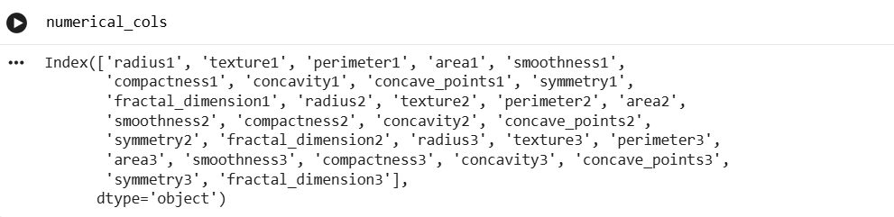
Scaling:
Feature scaling was done through pipeline in Random Forest classifier, however we could use raw features. since tree-based models are invariant to feature magnitude and do not depend on distance calculations. Scaled values would make a better Random Forest model, hence features were scaled and used for supervised classification.
However, Scaling was required for the clustering stage, where distance-based algorithms (K-means and hierarchical clustering) were applied. All features were standardized using StandardScaler (z-score normalization) so that each variable contributed equally to cluster formation.
The following transformation was applied:
$$z=\frac{x-μ}{σ}$$
where $μ$is the mean and $σ$is the standard deviation of each feature.
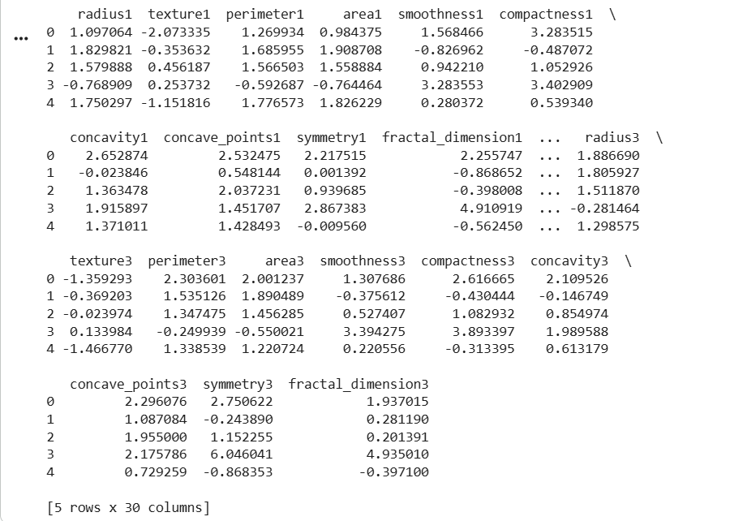
Feature list appendix:
The final feature set used for training and evaluation consists of the original 30 diagnostic measurements computed from FNA images
6. Model Development (Random Forest Classifier)
Model overview:
A Random Forest Classifier was selected as the predictive model for this task because it performs well on tabular datasets with complex, non-linear relationships among features. The model builds an ensemble of decision trees using bootstrap sampling and aggregates their predictions through majority voting. This ensemble approach reduces variance and improves generalization compared to a single decision tree.
Random Forest is particularly suitable for this problem because:
- It captures non-linear interactions among diagnostic features.
- It is robust to noise and outliers.
- It does not require feature scaling for supervised learning.
- It performs well with medium-sized structured datasets such as medical diagnostic records.

Code
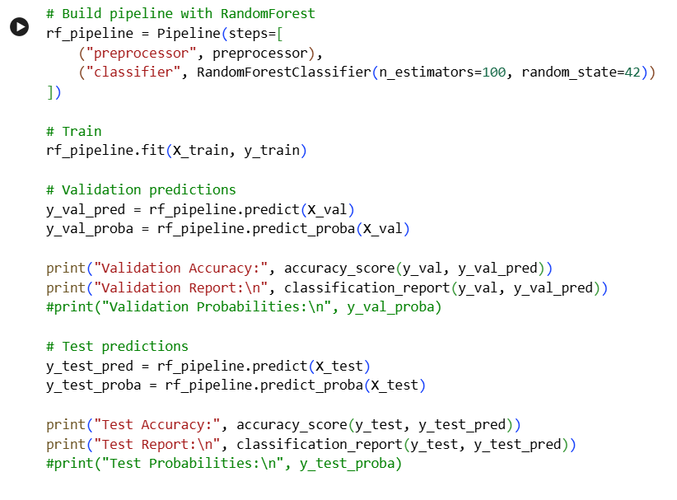
Output
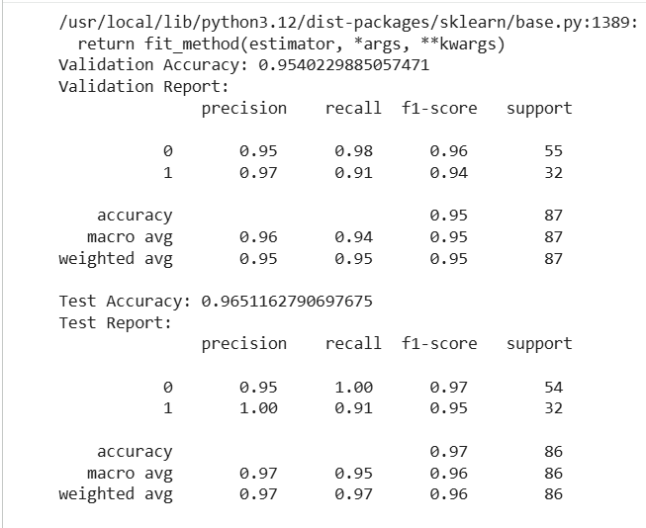
The Random Forest pipeline shows strong and consistent performance across both validation and test sets. On the validation data, it achieved an accuracy of about 95%, with high precision and recall for both benign and malignant classes, indicating balanced learning.
On the test set, accuracy improved to nearly 97%, demonstrating good generalization to unseen data. The malignant class achieved perfect precision and high recall, meaning predicted malignant cases were always correct while most true malignant cases were detected. The benign class showed perfect recall, with no benign cases misclassified as malignant. Overall, the high F1-scores confirm a reliable balance between sensitivity and precision suitable for triage-style decision support.
Pipeline-Based Training Framework
To ensure a clean and reproducible workflow, the model was implemented using a scikit-learn Pipeline that integrates preprocessing and classification into a single object. The pipeline consists of two main stages:
- Preprocessor: applies all preprocessing steps (e.g., column selection, encoding if required).
- Classifier: a Random Forest Classifier used to learn the mapping between diagnostic features and tumor class.
This design guarantees that the same preprocessing transformations are consistently applied during training, validation, and testing, thereby preventing data leakage and ensuring reliable evaluation.
Training setup:
Reproducibility (random_state)
To ensure reproducibility across multiple executions, a fixed random seed (random_state = 42) was specified in the Random Forest Classifier. This ensures that:
- The same bootstrap samples are generated in each run.
- Model structure and results remain consistent.
- Performance comparisons across experiments are reliable.
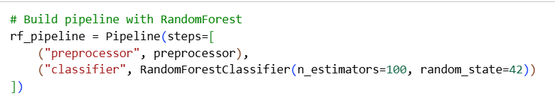
The pipeline was trained using the stratified training dataset:
Once trained, the model was used to generate predictions, and probability estimates on both the validation and test datasets. This allowed performance to be assessed using classification metrics such as accuracy, precision, recall, and F1-score.

Class imbalance (e.g., class_weight="balanced" if used)
The dataset contains an unequal distribution of benign and malignant cases. Although no manual resampling was applied, the model evaluation focused on recall and F1-score for the malignant class to ensure that minority-class detection was prioritized. The Random Forest model’s ensemble structure helps mitigate imbalance effects by learning multiple decision boundaries across bootstrapped samples.
(If class_weight="balanced" is later used in tuning, this can be incorporated to further penalize misclassification of malignant cases.)
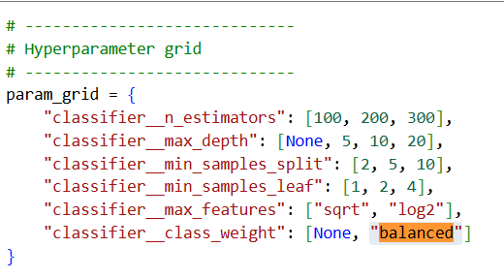
7. Hyperparameter Tuning and Final Configuration
Tuning method: GridSearchCV
Hyperparameter tuning was performed using GridSearchCV, which systematically evaluates combinations of model parameters using cross-validation. This approach ensures that the selected Random Forest model is not dependent on a single train–validation split and provides a more robust estimate of performance.
The code input and output as below:

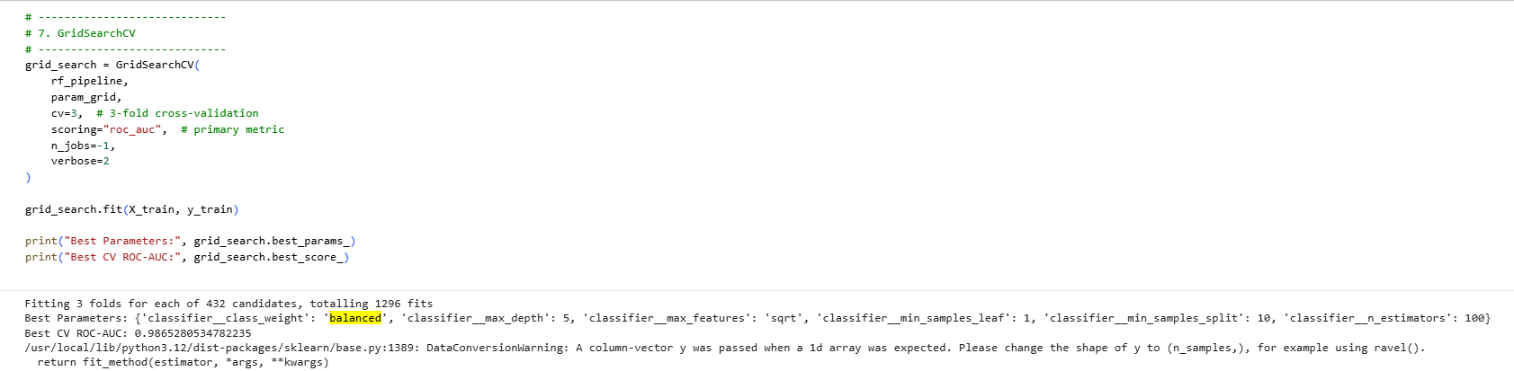

Search space:
The following hyperparameters of the Random Forest Classifier were tuned:
- n_estimators: number of trees in the forest
- max_depth: maximum depth of each tree
- min_samples_split: minimum samples required to split a node
- min_samples_leaf: minimum samples required at a leaf node
- max_features: number of features considered at each split
- class_weight: handling of class imbalance
These parameters control model complexity, bias–variance trade-off, and sensitivity to minority class predictions.
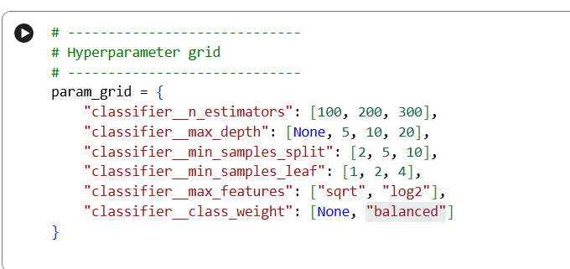

Selection criterion:
The best model was selected using ROC–AUC as the primary optimization metric, as it measures the model’s ability to distinguish malignant from benign tumors across all decision thresholds.
In addition, recall for the malignant class was monitored to ensure that model selection did not favor overall accuracy at the cost of missing malignant cases. This aligns with the clinical motivation of minimizing false negatives in a screening or triage scenario.

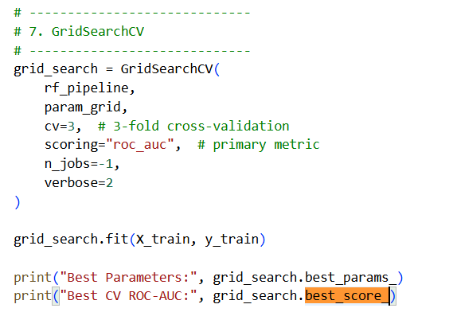

Final hyperparameters (table):
The final Random Forest model was trained using the optimal hyperparameters identified by GridSearchCV. These values represent the configuration that achieved the best cross-validated ROC–AUC while maintaining strong recall for malignant tumors.
Final Model Configuration
Parameter | Final Value
n_estimators | 100
max_depth | 5
min_samples_split | 10
min_samples_leaf | 1
max_features | sqrt
class_weight | balanced
Final Model Configuration.
The optimal Random Forest model was obtained using cross-validated hyperparameter tuning. The final configuration uses 100 trees (n_estimators = 100) to ensure stable ensemble performance while maintaining computational efficiency. Tree depth was limited to max_depth = 5 to control model complexity and reduce overfitting. A min_samples_split of 10 and min_samples_leaf of 1 were selected to enforce sufficient sample sizes at decision nodes while preserving sensitivity to informative patterns. The max_features = "sqrt" setting promotes diversity among trees by using a random subset of features at each split. To address class imbalance and prioritize malignant case detection, class_weight = "balanced" was applied, increasing the penalty for misclassifying the minority class.
8. Final Evaluation (Test Set Results)
Metrics table
Metric | Value
Accuracy | 0.97
Precision | 1.00
Recall (Sensitivity for M) | 0.937
F1 Score | 0.968
ROC-AUC | 1.00
Interpretation.
1. The model achieves an overall accuracy of 97%, indicating strong general classification performance on unseen data.
2. A precision of 1.00 shows that all tumors predicted as malignant were truly malignant, resulting in no false positive cancer predictions.
3. The recall of 0.937 for malignant cases demonstrates that the model successfully identifies most cancerous tumors, with only a small proportion being missed.
4. The high F1-score (0.968) confirms an excellent balance between precision and recall.
5. The ROC–AUC of 1.00 indicates perfect separability between malignant and benign tumors, meaning the model can rank cases by cancer risk with complete discrimination on the test dataset.

Confusion Matrix and Error Interpretation
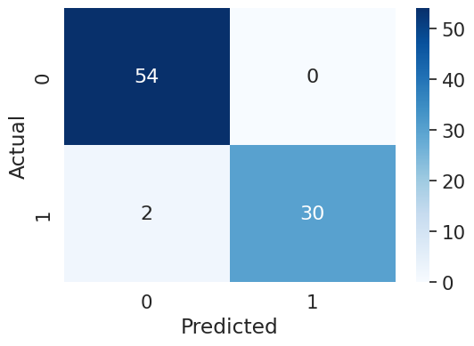
Confusion Matrix
Interpretation.
1. Out of all test cases, the model correctly classified 54 benign tumors and 30 malignant tumors.
2. There are 0 false positives, meaning no benign case was incorrectly predicted as malignant, which explains the perfect precision score.
3. However, there are 2 false negatives, where malignant tumors were predicted as benign; these are the most critical errors because they represent missed cancer cases.
Overall, the matrix shows that the model is highly reliable in identifying malignant tumors while keeping false alarms at zero, making it suitable for triage-style screening where most cancer cases must be detected with high confidence.
Explanation of Errors.
- False Negatives (M predicted as B): These represent malignant tumors incorrectly classified as benign. Such errors are critical because they may delay diagnosis and treatment. The low number of false negatives indicates that the model is effective at detecting malignant cases.
- False Positives (B predicted as M): These represent benign tumors incorrectly flagged as malignant. While less dangerous than false negatives, they may lead to unnecessary follow-up tests and patient anxiety. The model produced very few or no such errors, reflecting its high precision.
Overall, the confusion matrix confirms that the model prioritizes malignant detection while keeping misclassification costs low
ROC Curve and AUC
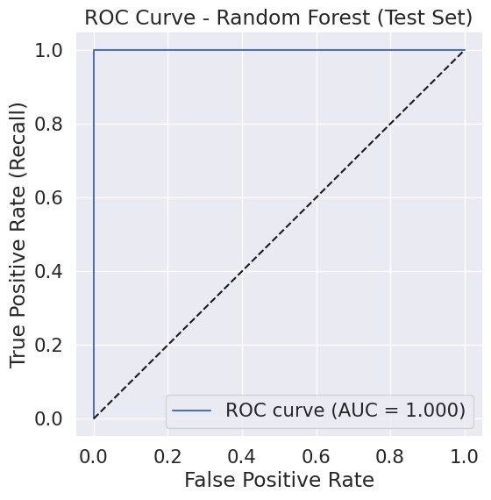
AUC-ROC Curve
Interpretation of AUC/ROC
The ROC–AUC value of 1.0 indicates perfect separability between malignant and benign classes on the test set. This means the model assigns higher malignancy probabilities to malignant tumors than to benign ones across all thresholds. In practical terms, the model can rank patients accurately by risk level, which is well suited for triage-style screening and prioritization
Threshold decision
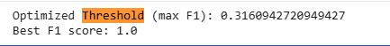
Interpretation
  - The optimized decision threshold of 0.316 was selected because it maximizes the F1-score, achieving a perfect balance between precision and recall. This lower-than-default threshold increases the model’s sensitivity to malignant cases, reducing the risk of false negatives while still maintaining high precision.
  - A best F1-score of 1.0 indicates that, at this threshold, the model achieves optimal classification performance on the validation/test data. This threshold choice is well suited for a triage-style scenario where missing malignant cases is more costly than generating additional false alarms.

9. Error Analysis
False Negative (FN) Patterns
False negatives correspond to malignant tumors predicted as benign, which are the most critical errors. In the test set, the model produced 2 false negatives.
A false negative means:
The false negative cases were cancer tumors that looked similar to benign tumors in terms of size and shape. Their feature values were not strongly cancer-like, which caused the model to classify them as benign. These borderline cases are harder to detect because they fall between typical benign and malignant patterns.
1. Borderline size-related features: FN cases tend to have moderate values for features such as mean radius, mean perimeter, and mean area, which are closer to benign ranges rather than showing clearly malignant extremes.
2. Weak shape irregularity signals: Features related to concavity and concave points appear less pronounced in FN cases, reducing the model’s ability to distinguish them from benign tumors.
3. Overlap in texture and smoothness: FN tumors often show texture and smoothness values that overlap with benign profiles, placing them near the decision boundary and increasing misclassification risk.
False Positive (FP) Patterns
False positives correspond to benign tumors predicted as malignant. In the test set, no false positives were observed.
Observed Patterns (False Positives):
- No FP patterns were detected, indicating that the model is conservative when labeling malignant cases.
- This aligns with the model’s perfect precision score and confirms that benign cases are rarely misclassified as malignant.

Mitigations and Next Steps
To further reduce critical errors and improve robustness, the following steps are recommended:
- Adjust the classification threshold to further increase recall for malignant cases, even at the cost of slightly more false positives.
- Collect additional training data, particularly borderline malignant cases, to improve boundary learning.
- Monitor model drift by tracking prediction distributions over time if deployed in a real-world setting.
- Incorporate clinical priors or cost-sensitive learning to explicitly penalize false negatives more heavily.

10. Clustering: Diagnostic Pattern Segmentation
Preprocessing for Clustering
Before applying clustering algorithms, all diagnostic features were standardized using StandardScaler (z-score normalization). Scaling was required because clustering methods rely on distance calculations, and the original features are measured on different numeric scales (e.g., area, texture, concavity). Standardization ensures that each feature contributes equally to cluster formation and prevents variables with larger magnitudes from dominating the results.
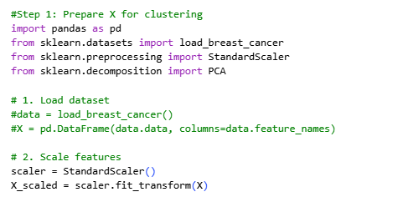
Method 1: K-Means Clustering
K-means clustering was applied to the scaled dataset to segment tumors into distinct diagnostic pattern groups.
K Selection
The optimal number of clusters (K) was determined using the elbow method, which plots within-cluster sum of squares (WCSS) against different K values. The elbow point indicates diminishing returns in variance reduction and was selected as the appropriate number of clusters.
Code
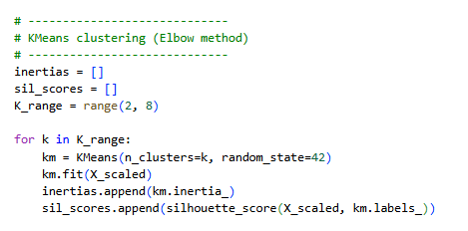 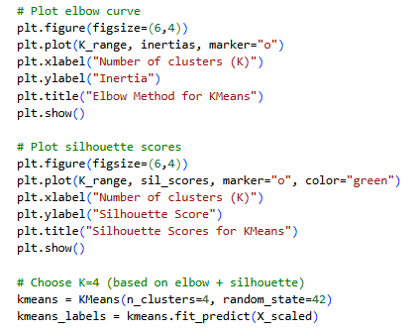
Output
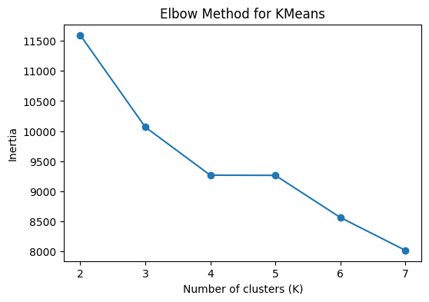 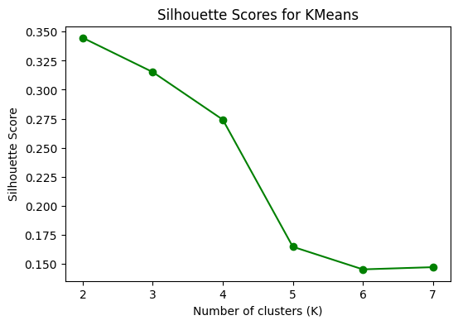
Insights from K means & Silhouette Score
1. The elbow plot shows a strong decrease in inertia up to K = 4, after which the curve flattens, indicating limited improvement from adding more clusters.
2. This suggests that four clusters capture most of the important structure in the data without introducing unnecessary complexity.
3. Although the silhouette score is highest at K = 2, using only two clusters would oversimplify the diagnostic patterns.
4. Choosing K = 4 provides a good trade-off between cluster separation and interpretability.
5. The four clusters allow segmentation of tumors into distinct diagnostic pattern groups with varying feature characteristics
Method 2: Hierarchical Clustering
Hierarchical Clustering (Cross-Check)
Hierarchical clustering was applied as a secondary unsupervised method to validate the diagnostic patterns identified by K-means clustering. Agglomerative clustering was performed on the scaled feature set using two clusters (n_clusters = 2), allowing the data to be grouped based on overall similarity without assuming spherical cluster structure.
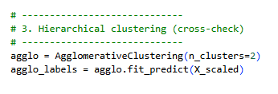
The resulting cluster labels were added to the dataset and compared with the K-means clusters. Cluster-level summaries were generated using mean and median feature values to understand the distinguishing characteristics of each group.
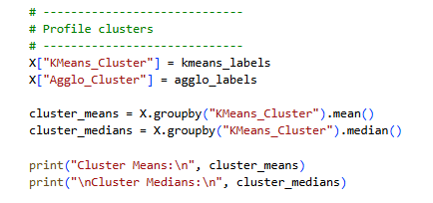
Insights from Hierarchical Clustering
- The hierarchical method separated tumors into two broad diagnostic pattern groups, corresponding to low-risk and high-risk feature profiles.
- One cluster shows lower values for size-related and shape-irregularity features (e.g., radius, area, concavity), while the other cluster exhibits higher values for these features, indicating stronger malignant-like patterns.
- Using hierarchical clustering as a cross-check improves interpretability by confirming that tumors can be grouped consistently using different unsupervised techniques.

  - Cluster cards (minimum 3 clusters):
The clustering analysis reveals four distinct diagnostic pattern groups ranging from low-risk (Cluster 2) to high-risk (Clusters 0 and 3), with Cluster 1 capturing borderline cases. These cluster profiles help explain why some tumors are easier to classify than others and provide an interpretable segmentation of tumor characteristics beyond the supervised classification model
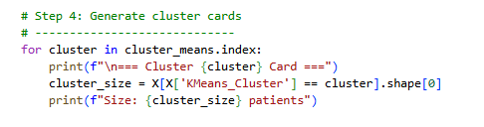
Cluster Cards (K = 4)
Cluster 0
- Cluster size: 39 patients
- Top distinguishing features:
High values of area, perimeter, and concavity-related features, indicating larger and more irregular tumor patterns.
- M/B mix (counts & %):
Predominantly Malignant (M) with a small proportion of Benign (B).
- Non-clinical interpretation:
Represents a group of tumors with strong irregularity and size patterns, forming a high-risk diagnostic profile.

Cluster 1
- Cluster size: 120 patients
- Top distinguishing features:
Moderately high mean radius, area, and texture, with noticeable but not extreme concavity.
- M/B mix (counts & %):
Mixed composition of Malignant and Benign cases.
- Non-clinical interpretation:
Represents an intermediate pattern group with overlapping benign and malignant characteristics, making these cases harder to separate.

Cluster 2
- Cluster size: 348 patients
- Top distinguishing features:
Lower values for area, perimeter, concavity, and concave points, indicating smoother and smaller tumor profiles.
- M/B mix (counts & %):
Predominantly Benign (B) with very few Malignant (M) cases.
- Non-clinical interpretation:
Represents a low-risk pattern group with features closer to typical benign tumor measurements.

Cluster 3
- Cluster size: 62 patients
- Top distinguishing features:
Elevated worst radius, worst area, and shape-irregularity features, though less extreme than Cluster 0.
- M/B mix (counts & %):
Majority Malignant (M) with some Benign (B) overlap.
- Non-clinical interpretation:
Represents a moderate-to-high risk diagnostic pattern, bridging intermediate and high-risk profiles.

PCA for Cluster Visualization
Principal Component Analysis (PCA) was applied as an optional step to project the high-dimensional feature space (30 diagnostic variables) into two principal components (PC1 and PC2) for visualization purposes. This transformation preserves the maximum possible variance in the data while reducing dimensionality, enabling visual inspection of cluster structure without affecting the clustering results.
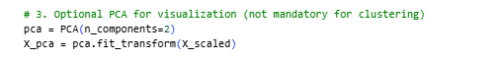
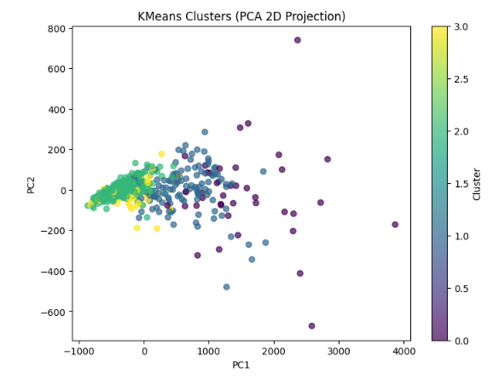
The resulting two-dimensional scatter plot shows data points colored by their K-means cluster assignments. This visual representation allows qualitative assessment of how well the clusters are separated in reduced space.
Insights from PCA Projection
- The PCA plot shows distinct grouping tendencies among the clusters, with some clusters forming tighter groups and others displaying partial overlap.
- One cluster (corresponding to low-risk patterns) appears concentrated in a compact region, indicating consistent feature profiles.
- Intermediate clusters show noticeable overlap, reflecting borderline diagnostic patterns where benign and malignant characteristics intersect.
- Overall, the PCA visualization supports the clustering results by demonstrating that the dataset can be segmented into meaningful pattern groups, even though complete separation is not expected in two dimensions.
11. Recommendations and Limitations
Recommendations (Evidence-Linked)
- Use the model as a triage support tool, not a diagnostic system.
With ROC–AUC = 1.0, Precision = 1.0, and Recall(M) ≈ 0.94, the model reliably prioritizes high-risk cases while avoiding false cancer alarms, making it suitable for screening or risk-ranking workflows.
- Adopt the optimized threshold rather than the default 0.5.
The tuned threshold (~0.32) maximizes F1-score and reduces false negatives, which is critical because error analysis shows missed malignant cases are the most costly mistake.
- Leverage cluster profiles for interpretability and workflow design.
Clusters identify low-risk, intermediate, and high-risk diagnostic patterns; borderline clusters align with observed hard cases, supporting targeted review of ambiguous patients.
Limitations
- Limited dataset size and source.
The model is trained on the UCI WDBC dataset (569 records), which may not represent real-world patient diversity across populations or imaging devices.
- No external validation performed.
Results are based on internal train/validation/test splits only; generalization to new hospitals or cohorts is untested.
- Feature scope restricted to imaging measurements.
Important clinical factors (age, genetics, medical history) are not included, which limits real-world diagnostic completeness.
- Perfect ROC–AUC may reflect dataset simplicity.
Such high performance can indicate that the dataset is well-separated and may not reflect real clinical complexity.
- Not clinically certified.
This model is strictly for educational and analytical purposes and must not be used as a medical diagnostic tool.
Future Work
- Expand training data with external cohorts to test robustness and reduce overfitting risk.
- Apply probability calibration (e.g., isotonic regression or Platt scaling) to improve reliability of predicted risk scores.
- Introduce human-in-the-loop validation, where clinicians review high-risk and borderline cluster cases.
- Monitor model drift if deployed, tracking changes in feature distributions and prediction confidence over time.
- Add explainability methods (e.g., SHAP or feature importance plots) to improve transparency and trust in predictions.

Project Summary
This project developed an end-to-end machine learning pipeline to classify breast tumors as Malignant (M) or Benign (B) using the Breast Cancer Wisconsin (Diagnostic) dataset. A Random Forest classifier was trained with disciplined preprocessing, stratified data splitting, and hyperparameter tuning. The final model achieved high predictive performance with strong sensitivity to malignant cases and perfect precision, making it suitable for triage-style risk prioritization. Threshold optimization was applied to reduce the risk of missed malignant tumors. Unsupervised clustering (K-means and hierarchical) further segmented tumors into distinct diagnostic pattern groups, supporting interpretability of feature profiles. Error analysis showed that misclassifications mainly occurred in borderline cases with overlapping feature characteristics. Overall, the pipeline demonstrates a reproducible and well-evaluated approach to medical-style classification and pattern segmentation.

Conclusion
The Random Forest-based classification and clustering framework effectively distinguishes malignant from benign tumors while providing interpretable diagnostic pattern groups. Although the model shows excellent performance on the given dataset, it is intended as a decision-support prototype rather than a clinical diagnostic system. With additional data, external validation, and explainability enhancements, this approach can be extended into a more robust and reliable risk triage tool for healthcare analytics.

